**Pps mini project**

**By Lakshay malik**

**Ra2111050010016**

# E -Library Management System

E-Library Management System where the user has the following options:

* Add book information.
* Display book information.
* To list all books of a given author.
* To list the count of books in the library.

**Functionalities Required:**

* If the user tries to add a book then the user must have to provide the below specific Information about the book as: o Enter Book Name: o Enter Author Name: o Enter Pages: o Enter Price:
* When the user tries to display all books of a particular author then the user must have to enter the name of the author:

o Enter the author name:

* The E-Library management System must be also capable of counting all the books available in the library.

Below is the program to implement the E-Library Management System:

// C program for the E-library

// Management System

#include <stdio.h>

#include <stdlib.h>

#include <string.h>

// Create Structure of Library

struct library {

char book_name[20];

char author[20];

int pages;

float price;

};

// Driver Code

int main()

{

// Create a instance

struct library lib[100];

FILE *database;

char ar_nm[30], bk_nm[30];

// Keep the track of the number of

// of books available in the library

int i, input, count;

database=fopen("library_data.txt","w");

i = input = count = 0;

// Iterate the loop

while (input != 5) {

printf("\n\n********######"

"WELCOME TO E-LIBRARY "

"#####********\n");

printf("\n\n1. Add book infor"

"mation\n2. Display "

"book information\n");

printf("3. List all books of "

"given author\n");

printf(

"4. List the count of book"

"s in the library\n");

printf("5. Exit");

// Enter the book details

printf("\n\nEnter one of "

"the above: ");

scanf("%d", &input);

// Process the input

switch (input) {

// Add book

case 1:

printf("Enter book name = ");

scanf("%s", lib[i].book_name);

fprintf(database,"%s \t", lib[i].book_name);

printf("Enter author name = ");

scanf("%s", lib[i].author);

fprintf(database,"%s \t", lib[i].author);

printf("Enter pages = ");

scanf("%d", &lib[i].pages);

fprintf(database,"%d \t", &lib[i].pages);

printf("Enter price = ");

scanf("%f", &lib[i].price);

fprintf(database,"%f \n \n", &lib[i].price);

count++;

break;

// Print book information

case 2:

printf("you have entered"

" the following "

"information\n");

for (i = 0; i < count; i++) {

printf("book name = %s",

lib[i].book_name);

printf("\t author name = %s",

lib[i].author);

printf("\t pages = %d",

lib[i].pages);

printf("\t price = %f",

lib[i].price);

}

break;

// Take the author name as input

case 3:

printf("Enter author name : ");

scanf("%s", ar_nm);

for (i = 0; i < count; i++) {

if (strcmp(ar_nm,

lib[i].author)

== 0)

printf("%s %s %d %f",

lib[i].book_name,

lib[i].author,

lib[i].pages,

lib[i].price);

}

break;

// Print total count

case 4:

printf("\n No of books in "

"brary : %d",

count);

break;

case 5:

exit(0);

}

}

fclose(database);

return 0;

}

**Output:**

* Displaying the functionalities and input for option 1:

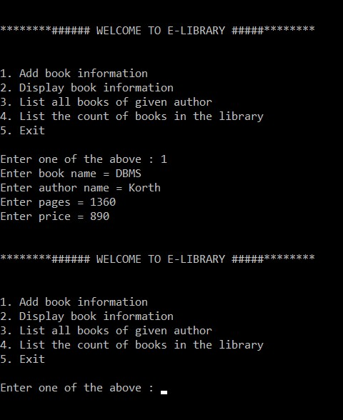

* 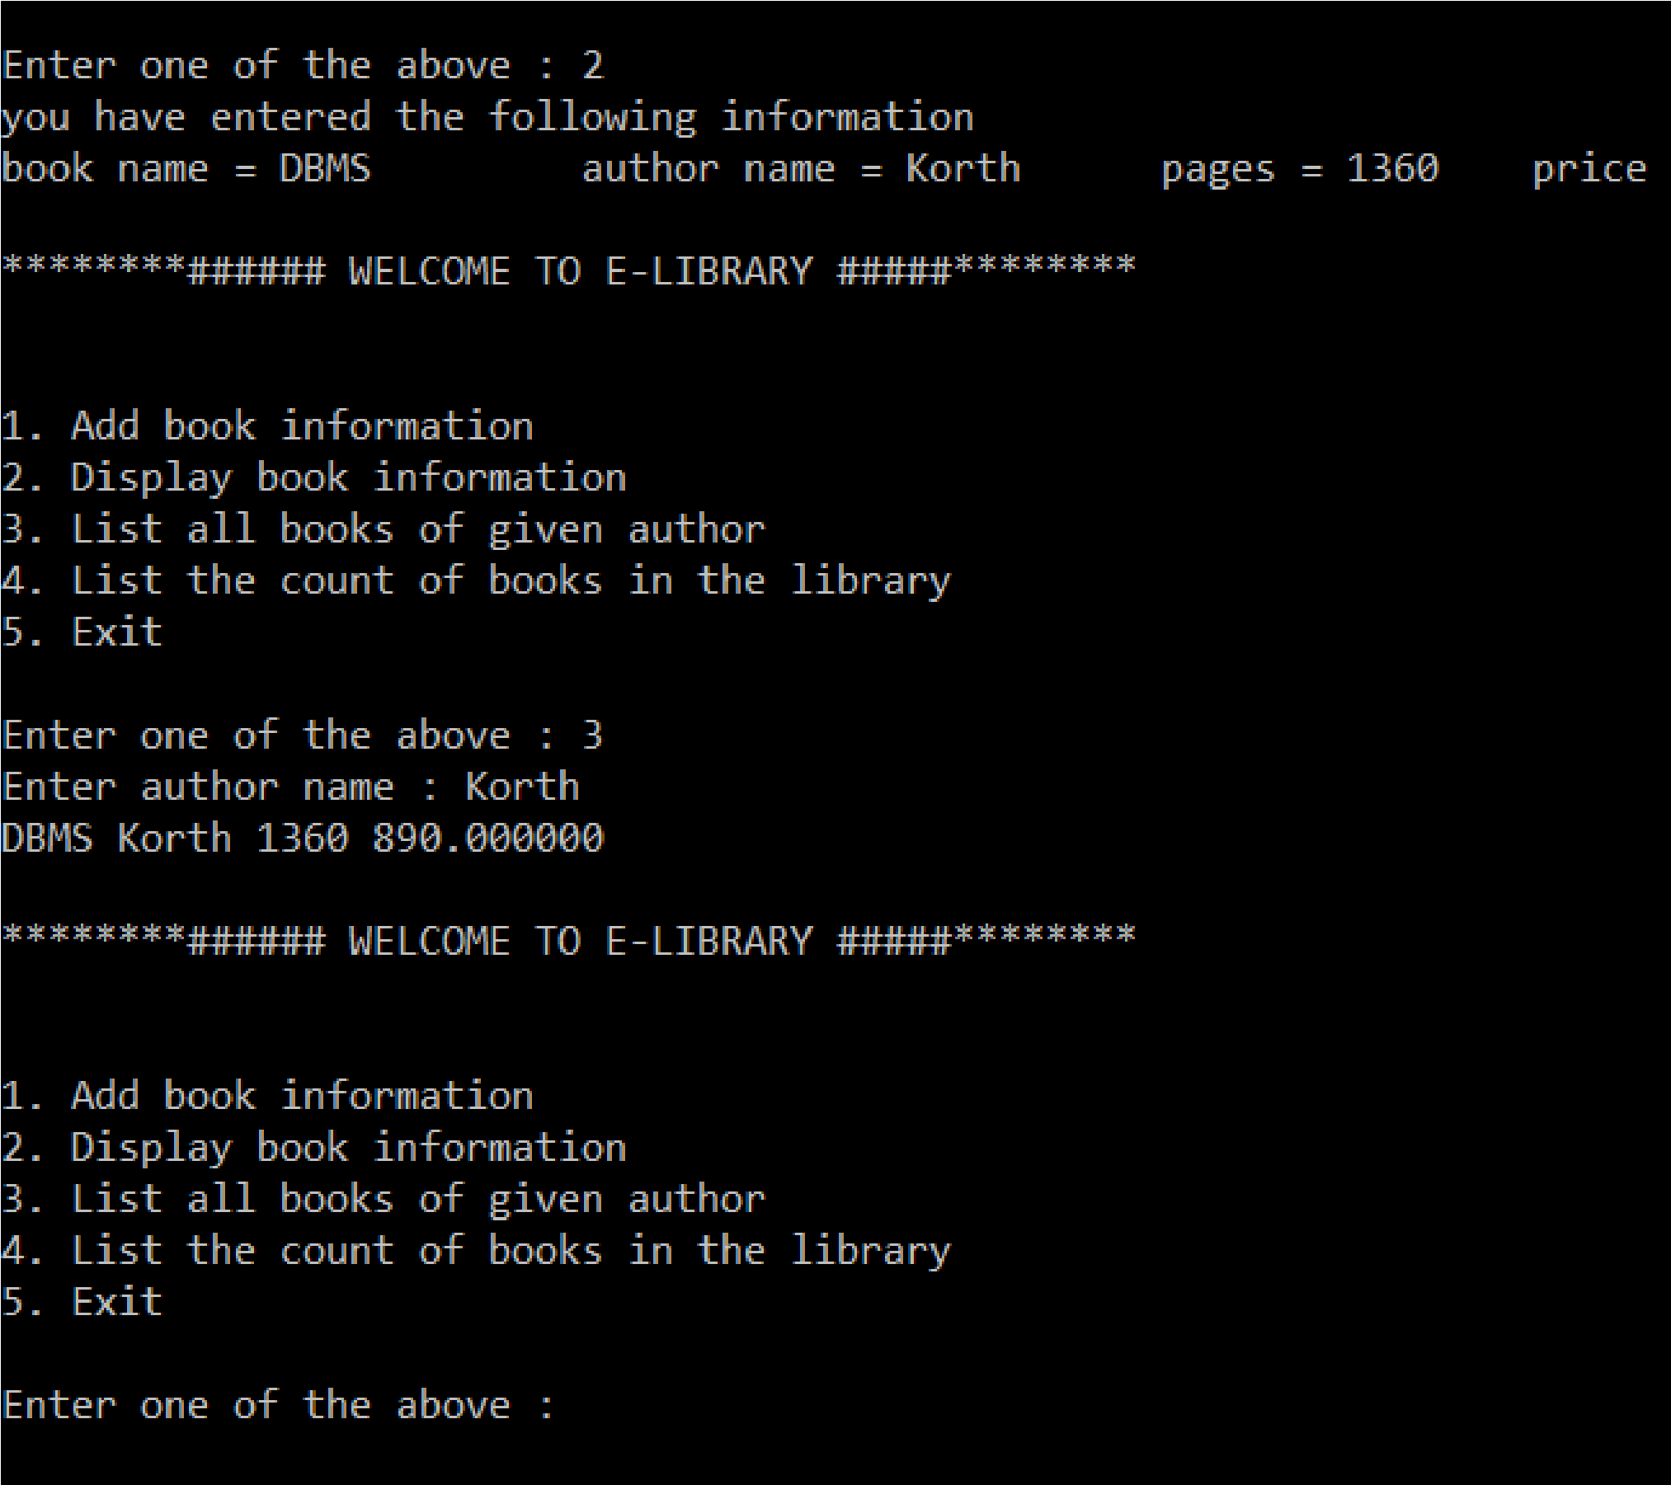For Choice 2 and 3:
* For choice 4 and 5:

